

**VOCATIONAL TRAINING REPORT**

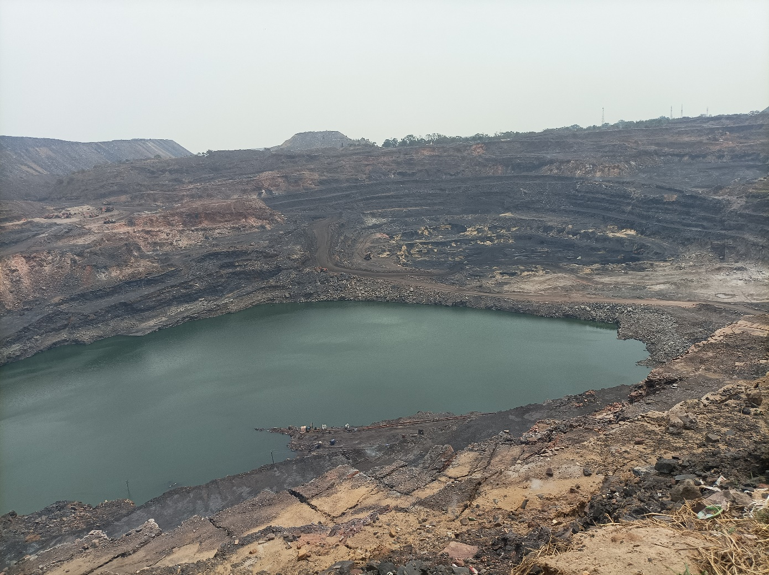

**Ena colliery Kusunda Area VI,**

**BCCL**

**By,**

**ANURAG KUMAR (19JEO170)**

**MINING ENGINEERING**

**IIT(ISM) DHANBAD**

**MINE TRAINING REPORT**

**DESIGN**

* It is having big sump at the bottom.
* It is said that this mine was underground before and now it is made opencast.
* We saw XIV seam bench.
* Mine consisted of 5 benches.
* Height of bench is approximately 25m.
* Coal is of washery III, washery IV quality.
* It is a fiery seam i.e. strata temperature is greater than 80 deg Celsius.
* 100 tons dumper of caterpillar is used.
* Production blasting is done in the morning.
* Weighbridge is also installed in the mine.
* Crusher is also installed in the mine.
* Coal depo is also made in the mine.
* 2 Payloader was also present there.
* River is also located beside the mine at safe distance.
* SME(site mixed emulsion) is used as explosive.

**BLASTING OPERATION**

* SME (site mixed emulsion) is used as explosive. It is the mixture of emulsion, ANFO, Diseal oil, water, chemical it is prepared at the site itself.
* At the site 6m hole was created and 3.5m stemming was given.
* There was problem with some hole it was very hot greater than 80 degree celcius that hole temperature was brought down by pouring water. Temperature was measured using contactless thermometer.
* For hot hole DF(detonating fuse) was used inside it PETN mixture is layered over wire inner surface.
* Emulsion booster was used as it can withstand high temperature and it is suitable for hot hole blasting.
* In normal temperature hole i.e. below 80 degree Celsius NONEL along with cast booster is used. Cast booster contains solid high explosive.
* 20 holes was blasted, 13 normal holes and 7 hot temperature holes.
* Exploder operated by battery is used to initiate blasting.
* First cast booster/emulsion booster in sack is put down the hole.
* Then SME is poured inside the hole and then stemming is given.
* In stemming sand and fly ash was used.
* Hole diameter was 114 cm.

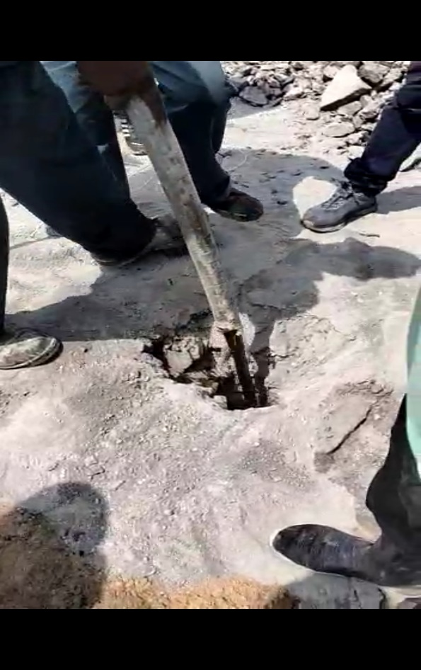

**FIG**-emulsion loading.

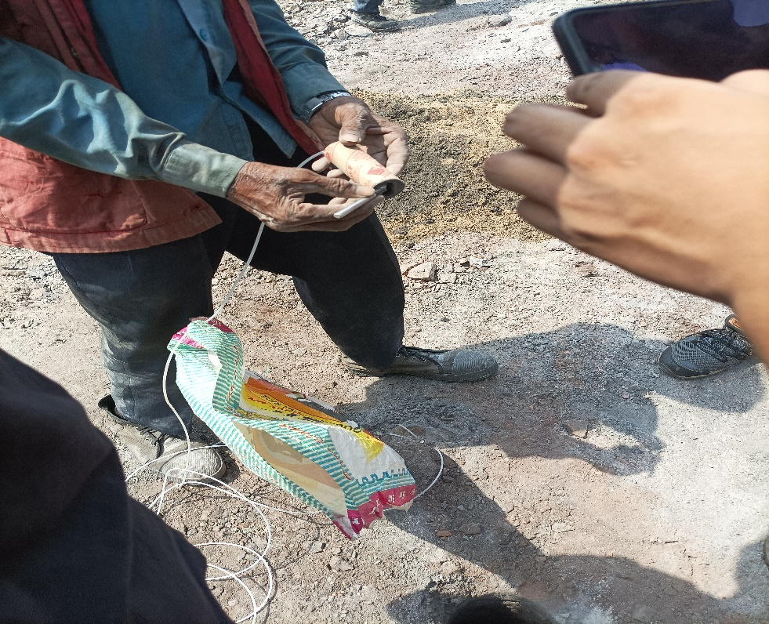

**FIG**- Cast booster used inside the hole.

**SURVEYING**

* Map is drawn on the scale of 1:2000.
* Total 14 seam is present in that area.
* Coal seam is determined by borehole drilling.
* Total lease area is 216 hectares(2.16km2).
* One river passes near from the open cast mines.
* 24m fault is present at the boundary in north side.
* At present work is going on in ix,x seam.
* Local residence is present near the mine planning is done to shift them to some other place.
* Two colliery is present in the west side.
* One colliery is also present at north side.

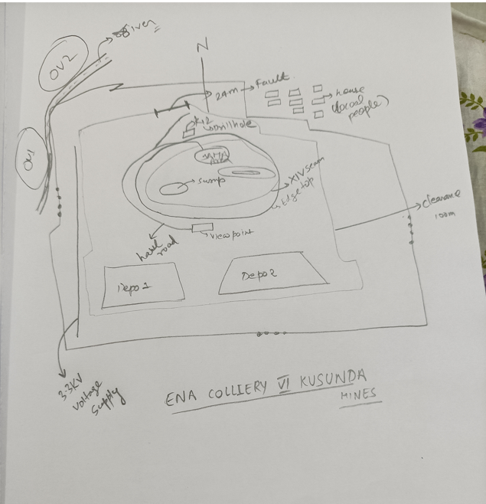

**FIG**- Rough map of the mine

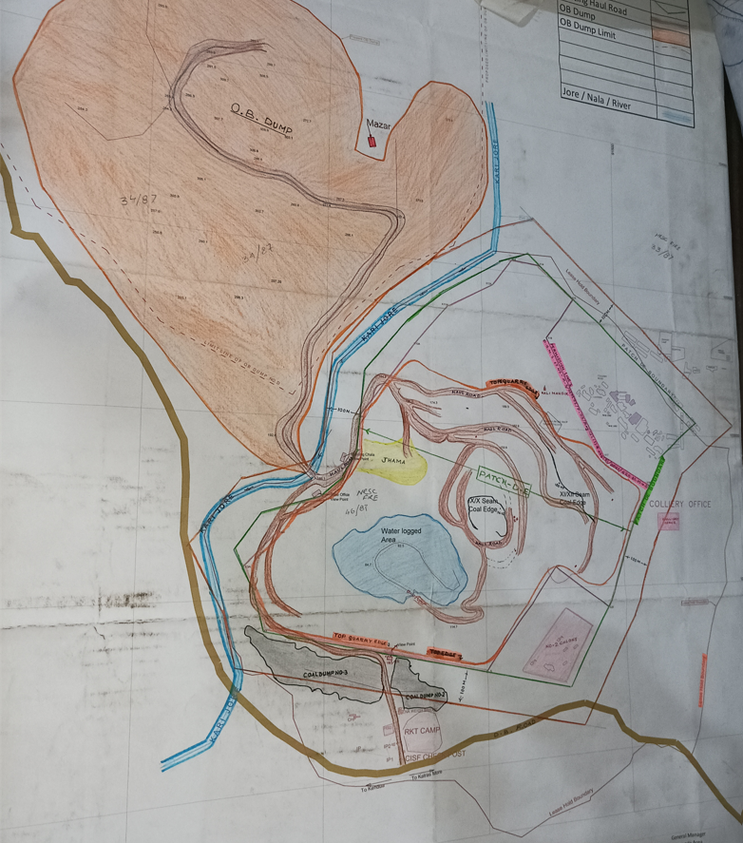

**FIG:-** Surveying data of the ena colliery Area VI.

**SAFETY MANAGEMENT PLAN**

* Principle hazards are Dust generation which can cause pneumoconiosis.
* Subsidence of land can take place because as we are working on underground developed seam.
* To avoid this where safe distance(parting) between two contiguous seam is less than 6m first hole drilling, charging, blasting and compaction by dozer is done before working.
* Fly rocks is also a major problem for that muffle blasting is suggested.
* Lighting problem is also a issue in the mines and collision may take place during night shift.

**PRODUCTION PLANNING**

* 6m3 shovel is used in the mines.
* Per shovel 5 dumper is used in the mines.
* 26 100 tonne dumper is present in the mines.

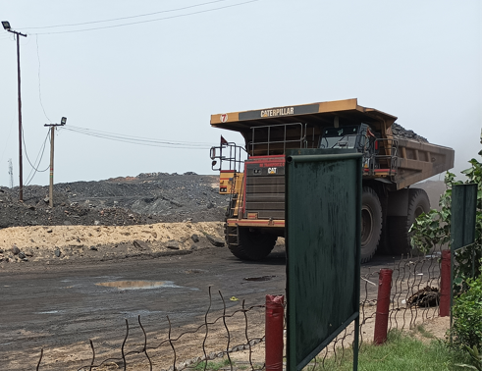

**FIG**:- 100 tonne dumper